**Project Design Phase-II**

**Technology Stack (Architecture & Stack)**

|  |  |
| --- | --- |
| Date | 06 May 2023 |
| Team ID | NM2023TMID11307 |
| Project Name | Estimation and Prediction of Hospitalization and Medical Care Costs |

**Technical Architecture:**

The Deliverable shall include the architectural diagram as below and the information as per the table1 & table 2

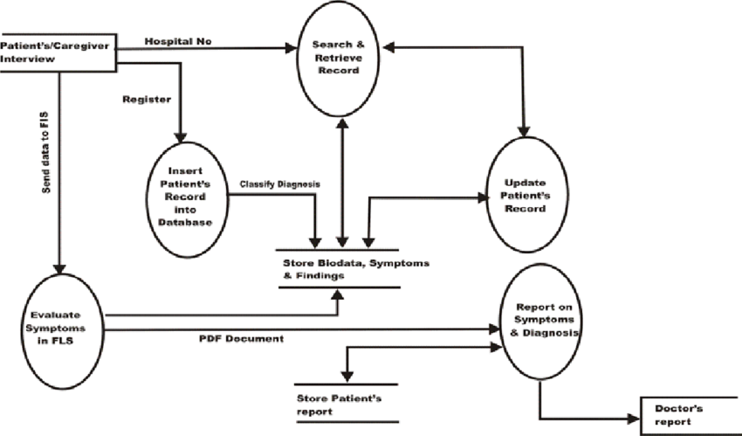

**Table-1 : Components & Technologies:**

|  |  |  |  |
| --- | --- | --- | --- |
| **S.No** | **Component** | **Description** | **Technology** |
|  | User Interface | The user interface layer provides the front-end components for users to interact with the system.  It includes web or mobile interfaces that allow healthcare providers, administrators, and other users to input patient data, access reports, and view cost estimates and predictions. | HTML, CSS, JavaScript / Angular Js / React Js etc. |
|  | Application Layer-1 | The application layer serves as the central processing unit of the system, handling the business logic and core functionalities. | Java / Python |
|  | Application Layer-2 | It includes modules for data validation, estimation algorithms, prediction models, and cost calculation. | IBM Watson STT service |
|  | Application Layer-3 | The application layer integrates with other system components, such as the database and external APIs. | IBM Watson Assistant |
|  | Database | The database layer stores and manages the system's data, including patient information, medical records, estimation models, and historical cost data.  .  The database layer also includes mechanisms for data retrieval, update, and backup to ensure data integrity and availability. | MySQL, NoSQL, etc. |
|  | Integration Services | The integration services layer facilitates communication and data exchange between the estimation and prediction system and external systems.  The integration services layer ensures seamless data flow and interoperability with other healthcare IT systems. | IBM DB2, IBM Cloudant etc. |
|  | Analytics and Reporting | The analytics and reporting layer encompasses components for generating reports, visualizations, and analytics based on the estimation and prediction data.  The layer may also include dashboards or reporting interfaces for users to access and customize reports based on their needs. | IBM Block Storage or Other Storage Service or Local Filesystem |
|  | Security and Privacy | The security and privacy layer incorporates mechanisms to protect the system and sensitive patient data.  .  The layer also implements encryption, secure communication protocols, and data anonymization techniques to safeguard patient privacy. | IBM Weather API, etc. |
|  | Scalability and Performance | The scalability and performance layer focuses on ensuring the system can handle increased data volumes, user loads, and computational requirements.  The layer may leverage cloud infrastructure or containerization technologies for scalability and elasticity. | Aadhar API, etc. |
|  | Monitoring and Management | The monitoring and management layer enables system administrators to monitor the system's health, performance, and resource utilization.  The layer may also include management interfaces for system configuration, maintenance, and troubleshooting. | Object Recognition Model, etc. |

**Table-2: Application Characteristics:**

| **S.No** | **Characteristics** | **Description** | **Technology** |
| --- | --- | --- | --- |
|  | Accuracy | The application should strive for high accuracy in estimating and predicting hospitalization and medical care costs.  The algorithms and models used should be well-calibrated and validated against real-world data to ensure reliable results | Technology of Opensource framework |
|  | Privacy and Security | It should incorporate robust encryption mechanisms, access controls, and data anonymization techniques to protect patient confidentiality and comply with relevant regulations (e.g., HIPAA or GDPR). | e.g. SHA-256, Encryptions, IAM Controls, OWASP etc. |
|  | Scalable Architecture | The application should be designed to handle a growing volume of patient data and increasing computational demands. It should be able to scale horizontally or vertically to accommodate additional users, data, and processing requirements. | Technology used |
|  | Adaptability | The application should be adaptable to changing healthcare policies, insurance coverage, and medical billing practices.  It should support updates and modifications to accommodate evolving regulations and industry standards. | Technology used |
|  | Performance | The application should incorporate performance monitoring capabilities to track system performance, identify bottlenecks, and optimize resource utilization. Monitoring tools and metrics help ensure efficient and reliable operation of the system.. | Technology used |